**“E-KETHA” : ENRICHING RICE FARMER’S QUALITY OF LIFE THROUGH A MOBILE APPLICATION.**

2022-81

Final Report

H.H.W.M.Binuka Sihan Paranagama

B.Sc. (Hons) Degree in Information Technology

Department of Computer Science and

Software Engineering

Sri Lanka Institute of Information Technology

Sri Lanka

September 2022

**“E-KETHA” : ENRICHING RICE FARMER’S QUALITY OF LIFE THROUGH A MOBILE APPLICCATION.**

2022-81

Final Report

H.H.W.M.Binuka Sihan Paranagama – IT19129372

Supervisor: Mr. Adeepa Gunarathna

Co Supervisor: Ms. Amali Upeka Gunasinghe

B.Sc. (Hons) Degree in Information Technology

Department of Computer Science and

Software Engineering

Sri Lanka Institute of Information Technology

Sri Lanka

September 2022

# **DECLARATION, COPYRIGHT STATEMENT AND THE STATEMENT OF THE SUPERVISOR**

We declare that this is our own work and this proposal does not incorporate without acknowledgement any material previously submitted for a degree or diploma in any other university or Institute of higher learning and to the best of our knowledge and belief it does not contain any material previously published or written by another person except where the acknowledgement is made in the text.

|  |  |  |
| --- | --- | --- |
| Name | Student ID | Signature |
| H.H.W.M.Binuka Sihan Paranagama | IT19129372 |  |

The supervisor/s should certify the proposal report with the following declaration.

The above candidates are carrying out research for the undergraduate Dissertation

under my supervision.

------------------------------ ------------------------------

Signature of the supervisor: Date:

------------------------------ ------------------------------

Signature of the co-supervisor: Date:

# **ABSTRACT**

In our country of Sri Lanka, rice is the most common type of food that is consumed in a daily basis. Due to that rice farmers face a huge amount of stress to supply according to the massive demand. One of the main problems rice farmers are currently facing is the improper use of fertilizers and the negative consequences due to it. These can range from harming the environment and the paddy itself then even to the humans. These topics was chosen due to there been recent reports of people getting sick. The aim is to develop a mobile application that will help farmers solve this particular problem. The application will use images to conduct image processing to analyze the area of the paddy field then again use image processing to identify the fertilizer belonging to the farmer. Finally machine learning and deep learning will provide the adequate dosage and the instructions.

Keywords :- rice crops, machine learning, image processing, deep learning, fertilizer

# **TABLE OF CONTENTS**

**DECLARATION, COPYRIGHT STATEMENT AND THE STATEMENT OF THE SUPERVISOR** iii

**ABSTRACT** iv

**TABLE OF CONTENTS** v

**LIST OF FIGURES** vi

**LIST OF TABLES** vi

**1.** **INTRODUCTION** 1

**1.1** **Background** 1

**1.2 Literature Survey** 2

**1.2.1 A nutrient recommendation system for soil fertilization based on evolutionary computation** 2

**1.2.2 On-line fertilizer recommendation system** 3

**1.2.3 Prediction of Crop Fertilizer Consumption** 3

**1.2.4 Integrated Fertilizer Management System (urvarak.nic.in)** 3

**1.3** **Research Gap** 4

**2.** **RESEARCH PROBLEM** 5

**3.** **OBJECTIVES** 7

**3.1 Main Objectives** 7

**3.2 Specific Objectives** 7

**4.** **METHODOLOGY** 8

**4.1 Methodology** 8

**4.1.1 Research Area** 10

**4.1.3 Design** 11

**4.2 Commercialization aspects of the product** 12

**4.2.1 Target audience** 12

**4.2.2 Design of the app** 12

**4.2.3 Gap in the market** 12

**4.2.4 Marketing plan** 13

**4.2.5 Pricing** 13

**4.2.6 Budget** 13

**5. Testing & Implementation** 14

**5.1 Implementation** 14

**5.1.1 Pre-processing** 14

**5.1.2 Modal** 14

**5.2 Testing and Maintenance** 15

**6. RESULTS AND DISCUSSION** 16

**6.1 Results** 16

**6.1.1 IDENTIFY FERTILIZER TYPE:** 16

**6.1.2 CALCULATE THE SIZE OF THE PADDY FIELD** 18

**6.2 Research Findings** 18

**6.3 Discussion** 19

**6.4 Summary of Each Student’s contribution** 19

**Conclusions** 19

**REFERENCE LIST** 20

**Glossary** 21

**Appendices** 22

# **LIST OF FIGURES**

Figure 1: Paddy production according to the fertilizer usage 1

Figure 2:Increase of problems due to high improper fertilizer usage 2

Figure 3: Heath concerns in Buea 5

Figure 4:2013 Sri Lanka's Fertilizer consumption 6

Figure 5: fertilizer recommendation overview 8

Figure 6:fertilization stages 9

Figure 7:Training accuracy chart 16

Figure 8:Training Loss chart 17

Figure 9:Fertilizer type prediction output 17

Figure 10:Area calculation 18

# **LIST OF TABLES**

Table 1: Comparing existing application and our application features 4

Table 2:Model accuracy 16

# **INTRODUCTION**

## **Background**

As the most popular food in Sri Lanka [1] that is concerned in a daily basis, rice has quite the high demand. One of the prime reasoning for not been able to fulfill this requirement is the improper use of fertilizers affecting the crops negatively.

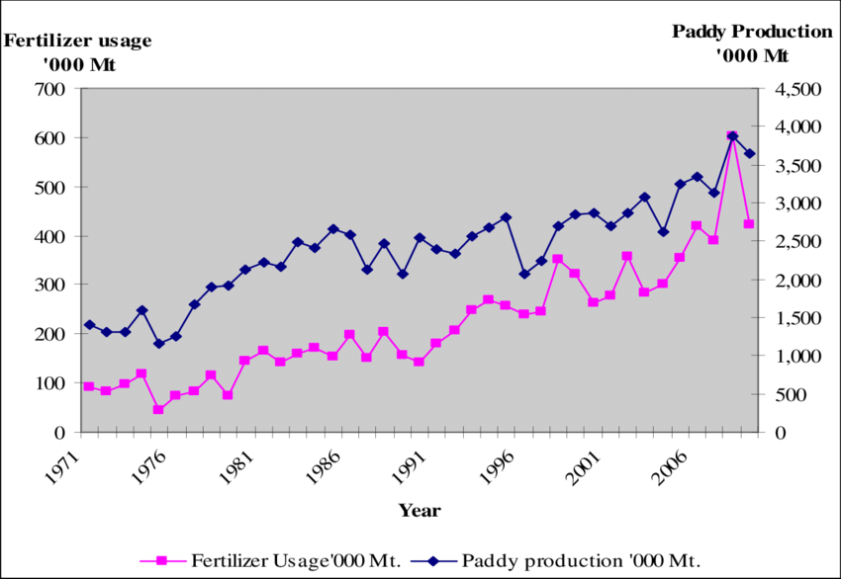

Figure 1: Paddy production according to the fertilizer usage

As it is shown in the above figure 1 [2] during the period of 1971 – 2010 the use of fertilizers has steadily increased in the country of Sri Lanka with it directly impacting the production of paddy. In the time duration of 1988 – 1991 there is a fluctuation in the usage of fertilization and if we see the same time period of paddy production the same exact fluctuation can be seen as well.

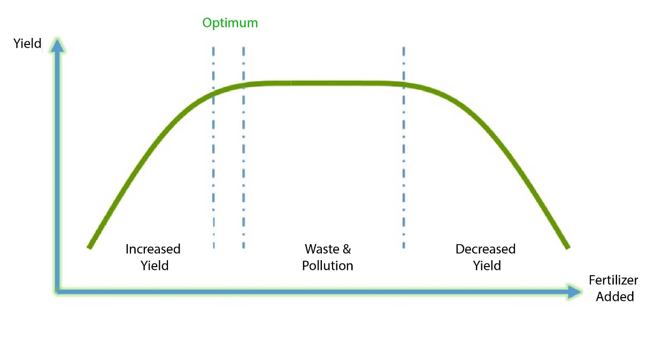

Figure 2:Increase of problems due to high improper fertilizer usage

When it comes to negative effects of improper fertilizer usage the above figure 2 [3] can be used as evidence. While reaching the optimum point, yield will steadily increase and after the optimum point, the surroundings will be polluted due to the buildup toxicity. And it further continued even the crops will be harmed.

As a solution for all these issues a mobile application will be proposed.

## **1.2 Literature Survey**

In literature survey I have looked for the same research areas and functionalities that are related to my research.

### **1.2.1 A nutrient recommendation system for soil fertilization based on evolutionary computation**

This study [4] is about predicting the fertilizers for different crops and give nutrients recommendations by analyzing the crop fertility and yield production. However, this application is limited to selected fertilizers (Nitrogen (N), Phosphorus (P), and Potassium (K)). This recommendation done by using improved genetic algorithm (IGA) which will uses time-series sensor data and recommends various crop settings. By analyzing the way that fertilizer works, the application will be able to give instructs farmers to get the maximum yield output.

### **1.2.2 On-line fertilizer recommendation system**

This application [12] will require several inputs from the user(Select state, select district, select soil type, select crop, select crop variety, select season). After providing the required information, the dominant of cropping systems in his district, the average soil fertility status of the district and also the agroclimatic zone in which the district occurs will be shown to the farmer. Finally when submitting farmer will be given the required quantities of nitrogen, phosphate, potash and straight fertilizers are shown in order to get the desired yield target. This application is available up-to 18 states.

Access : <http://www.nic.in/>

### **1.2.3 Prediction of Crop Fertilizer Consumption**

This research [13] is focused on identification of nitrogen deficiency and prediction of fertilizers consumption in chilly. First images of chilly are taken in two stages. Leaf part will be used to identification of nitrogen deficiency. This application will give proper guidance for optimal usage of these fertilizers and also get the required yield outcome that the farmers are expecting by minimizing wastage.

### **1.2.4 Integrated Fertilizer Management System (urvarak.nic.in)**

Integrated Fertilizer Management System (iFMS) [14] is functional since 2016 June. This system continues all the functionalities regarding the fertilizer supplier chin.

Uses of the application will be able to monitor all the fertilizer sales all over the country. To keep up the system up to date, application will gather fertilizer information from Aadhaar enabled PoS devices and update the software according to the information gathered, while making the payment to the participated companies on a weekly basis.

Access : <https://dbtfert.nic.in/iFMS/>

## **Research Gap**

The proposed application is to provide farmers proper guidance of how to apply fertilizers. Although there are several existing applications found, majority of them doesn’t achieve the main goal which is to give proper guidance to the farmers on how to fertilize their paddy field with their preferred fertilizer. The proposed application will have the ability to achieve the above mentioned goal.

|  |  |  |  |  |  |
| --- | --- | --- | --- | --- | --- |
| Feature | A nutrient recommendation system | On-line fertilizer recommendation | Prediction of Crop Fertilizer | iFMS | E - Ketha |
| Calculate paddy area | ✕ | ✕ | ✕ | ✕ | ✓ |
| Identify fertilizer | ✕ | ✕ | ✕ | ✕ | ✓ |
| Recommend fertilizer | ✓ | ✕ | ✕ | ✕ | ✓ |
| limited fertilizer range | ✓ | ✕ | ✕ | ✕ | ✓ |
| Able to use for rice plant | ✓ | ✓ | ✕ | ✕ | ✓ |
| Provide guidance | ✓ | ✓ | ✓ | ✕ | ✓ |
| Monitor fertilizer sales | ✕ | ✕ | ✕ | ✓ | ✓ |

Table 1: Comparing existing application and our application features

# **RESEARCH PROBLEM**

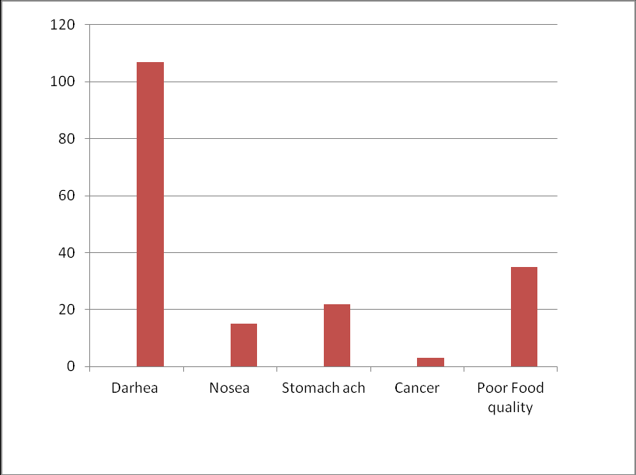Recognition of suitable fertilizers that are needed for the crops to grow healthy and abundant. Farmers due to lack proper guidance tent to use incorrect fertilizers, not only it effects the yields, fertilizers also have considerable side effects or even the correct fertilizers in wrong amounts thus making it harmful. This has become a major problem in Sri Lanka today due there being reports of various health concerns for the consumer such as increasing the risk of Alzheimer’s disease and Diabetes [5]. At worst, these fertilizers can cause the risks being expose to cancer in both adults and children adversely affecting fetal brain development [6] [7] [8].

.

Figure 3: Heath concerns in Buea

Above figure 3 [9] represent the average health issues occurred in Buea, Cameroon caused due to improper use of fertilizers.

Figure 4:2013 Sri Lanka's Fertilizer consumption

According to the local newspaper [16] which was published in 2013, The World health Organization warded Sri Lanka because of high fertilizer consumption. At that time Sri Lanka was ranked as the number 1 country when it comes to fertilizer consumption among Asian countries. Above figure 4 [17] shows the fertilizer consumption amounts in 2013.

The environment is also damaged as a repercussion, examples being contaminated waterways, soil pollution and the destruction of algae [10] [11]. Therefor there is need of a proper guidance system which helps the farmers to continue their farming while preventing these issues.

## **OBJECTIVES**

### **3.1 Main Objectives**

Introduce a mobile application to Identify the fertilization information. Then give guidance to the farmer on how to use it properly according to fertilizer type.

The main objective of the application is to give proper guidance to the farmer on how to use fertilizers. In order to do that user will have the ability to take a picture of rice fields and fertilizers. This will help to identify the best utilization methods with detailed instructions including amount and dosage of fertilization that could be used to aid their growth using the machine learning. Then the farmer can easily conduct the fertilization according to the instructions given by the application.

### **3.2 Specific Objectives**

1. Calculate the area of the paddy field.

By using this paddy image taken by the farmer, first the application will analysis the image and calculate how much of a area does that particular paddy field contains. This information will be further used for the task of providing instructions.

2. Identify the fertilizer type.

By analyzing the fertilizer image, application will identify which type of a fertilizer that the farmer is trying to apply.

3. Providing the information on how to use the fertilizer properly.

After the completion of first 2 phases, application will analysis and get the optimum solutions to the farmer on how to fertilize their paddy field properly.

# **METHODOLOGY**

## 

## **4.1 Methodology**

This section consists of a description about the techniques, mechanisms which will be used and what are the data sources and how they will be collected to build up this “Fertilizer recombination system”.

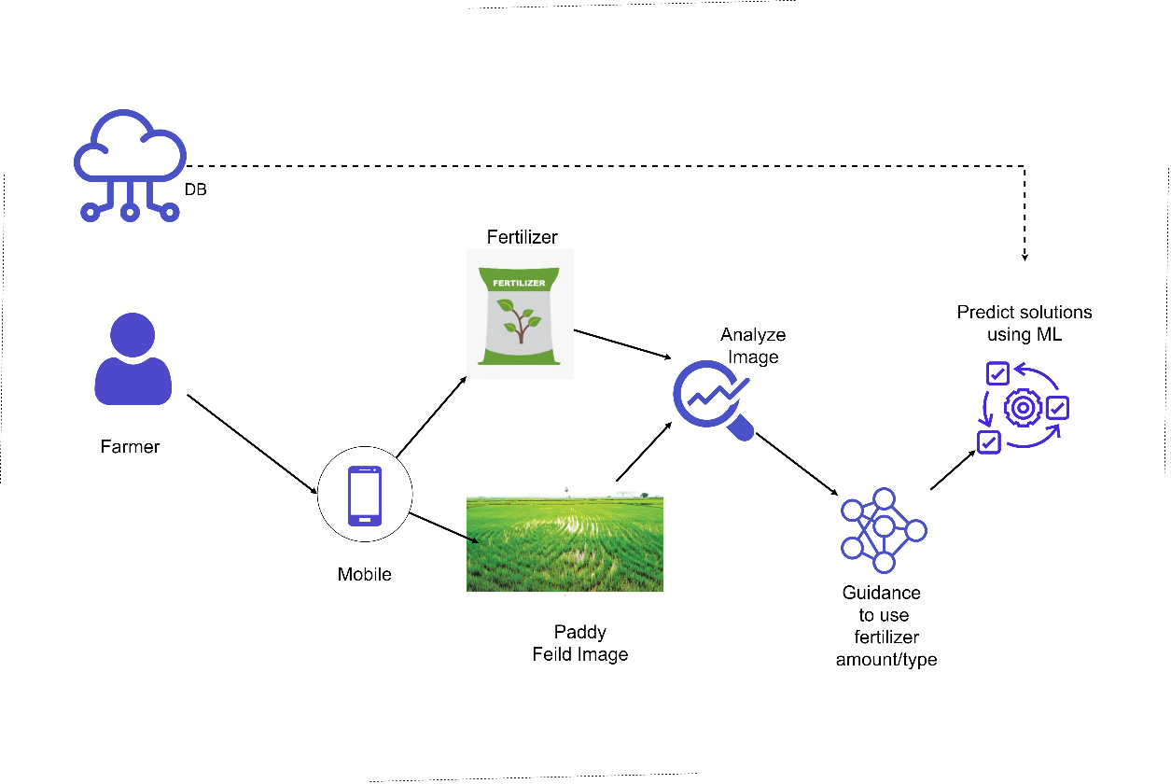

Figure 5: fertilizer recommendation overview

S shown in the figure 4 this component has 3 major functionalities.

1. Calculate the area of the paddy field.

To give proper guidance for the farmer, first we need to identify how much of paddy field does the farmer needs to fertilize. By using this information the application will be able to give exact fertilizer amounts that has to apply for a specific paddy field. In order to predict this image processing technology will be used to identify and calculate the area of the specific paddy field. Farmer just have to take an image of the paddy field by using their mobile’s camera and the application will analyze the image then record the information.

2. Identify the fertilizer type.

To identify which type of a fertilizer that farmer is trying to use, image processing will be used. In this phase also farmer has to take a picture of the fertilizer. Then the application will analyze the fertilizer image to identify type of the fertilizer. In order to do this application will keep up a labeled image dataset of fertilizers. Results gained from recognition process will be recorded. Later this information will be used to predict optimum solutions.

3. Providing the information on how to use the fertilizer properly.

After the first 2 phases completed to predict the optimum outcome machine learning algorithms will be used. By using the fertilizer type application will look for the best ways of utilizing that particular fertilizer. Then the by using the paddy field area the application will give a proper guidance for the farmer on how to utilize the fertilizer. What amount should be applied, How the fertilization has to conduct, What are fertilization during different time phases, etc.. Refer the figure 5 [15].

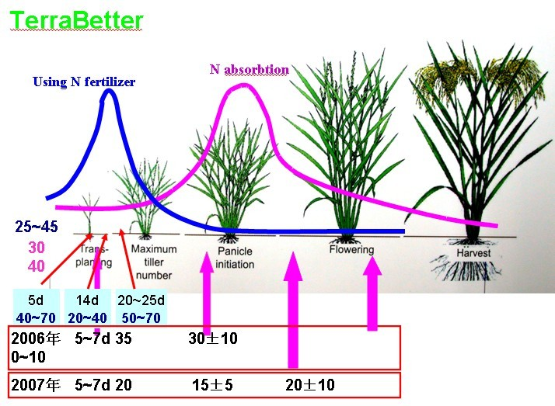

Figure 6:fertilization stages

## **4.1.1 Research Area**

When it comes to research area, four features were identified. Such as Image processing activities, Classification activity, Detection activities and finally solution prediction. In order to conduct the research, deep learning technology has been taken as the core foundation.

**4.1.2 Requirement Gathering and Analyzing**

Due to the importance of requirement gathering and analysis, major emphasis was put to this section. Since there is a need for this process to be strictly on the “fertilizer management” part below mentioned approaches were used.

* Reading research papers relevant to the research problem.
* Studying existing systems related to our research area.
* Contacted experts in Rice Research and Development Institute(RRDI) , Bathalagoda.
* Met with Sri Lankan paddy farmers.

To get an idea about the research problem, studying related research papers are a must. Next step was to understand what types of systems that already exists, so as to see what are lacking and needs improvements. Finally to see if the proposed solution is viable in the current environment, specialists on the field and traditional farmers were contacted.

#### **4.1.2.1 Functional requirements**

* Ability to upload paddy field imagery.
* Calculate paddy field area.
* Ability to upload fertilizer imagery.
* Identify fertilizer type.
* Propose solutions.
* Show proposed solutions.

#### **4.1.2.2 Non-functional requirements**

* Reliability
* Accuracy
* Availability
* Performance
* User friendly

## 

## **4.1.3 Design**

Design phase encompasses what is needed for the estimation of hardware and system requirements by the creation of a system architecture, due to the needs and specifications being included. The architecture will entail the components separated into manageable levels according to the respective research project member. In this case it will be the “fertilizer management” component.

**4.1.4 Tools and Technologies**

#### **4.1.4.1 Tools**

* Android studio
  + This is chosen due to it being the primary IDE recommended for Java mobile application development. The user friendliness coupled with the performance, security and feature richness also makes this most suitable option.
* Google collab
  + Since some of the deep learning models requiring high amounts of computational resources a virtual environment like google collab most appropriate.
* Google drive
  + Since google collab is used for the model training, the dataset cannot be stored in personal computers thus google drive is need for storing the dataset.

#### **4.1.4.2 Technologies**

* Deep learning
  + Deep learning is the only solution for image classification and identification tasks such as this. Due to there being no similar prior work, a model has to be created and trained from scratch.
* Models
  + CNN
    - A custom CNN model was identified to be the best for the identification of fertilizer.

The evidence for this is provided below within the methodology.

* Android Java
  + Since the application is initially targeted towards android devices, in order to provide the smoothest experience possible native android java is used.
* Firebase
  + Due to the application requiring real time online connection to the database firebase is chosen as the primary database. Since the data set mostly consist of images the need for a document-based database is further insinuated.
* Python
  + For the machine learning and deep learning parts of the application python is used due to the wide range of libraries and frameworks available for such tasks compared to other languages. The simplicity and consistency with the large community is also a benefit.

**4.1.5 Data acquisition**

A custom-made dataset has been created for this component which contains 785 images split into 4 different fertilizer types has been used for the model training and they are " Muriate of Potash (MOP)", " Triple Super Phosphate (TSP) ", "Urea" and "Zinc Sulphate" used for providing fertilization solutions according

## **4.2 Commercialization aspects of the product**

### **4.2.1 Target audience**

The primary target audience for this application will be rice farmers with rice suppliers, researchers, buyers, sellers, and any person who is connected to rice farming process being the secondary audience.

### **4.2.2 Design of the app**

A comprehensive and easily understandable UI and UX is created so that even non tech savvy users will not be confused while using the application. This will make sure that the application will reach a wide audience.

### **4.2.3 Gap in the market**

Currently in the play store, there is no other similar application to be found. This already makes the application unique and standout.

### **4.2.4 Marketing plan**

The initial incentive will be to introduce this application to the farmers themselves. This will enable us to get feedback directly from the primary target audience which will then make it easier to enhance and optimize the application further, thus making a better product.

This application will be promoted by famous influencers and through social media platforms.

### **4.2.5 Pricing**

Most of the functionality will be provided free with them including,

* Pest identification
* Disease identification
* Weed identification
* Fertilizer type identification
* Weed mapping
* Growth deficiency identification

This will be with free application.

In order for the solution providing functionality associated with the above-mentioned features to be enabled, a small price will have to be paid in a monthly basis.

### **4.2.6 Budget**

A price will have to be allocated for the influencer and social media promotions. In order to publish the application another, sum also has be assigned. Finally, the database will also be requiring of a monthly payment.

# **5. Testing & Implementation**

## **Diagram Description automatically generated5.1 Implementation**

In this stage of the project, the implantation of the system will be started. This will be in accordance with the system architecture proposed in the previous design phase. “Identification weeds and proposing solutions” component will be further split into three subcomponents, with them being

* Calculate paddy area using paddy imagery
* Identification of fertilizer using imagery
* Proposing solutions.

### **5.1.1 Pre-processing**

When it comes to pre-processing all the models that are described below went through the same process. Which includes shuffling, resizing, rescaling, flipping horizontally and vertically. Finally, normalization was performed according to the mean and standard deviation calculated for the datasets.

### **5.1.2 Modal**

#### **5.1.2.1 IDENTIFY FERTILIZER TYPE:**

TensorFlow Keras model is used for creating this model. Customized CNN was used as the main model for fertilizer identification. CNN was chosen due to it being one of the most basic deep learning models which can take input images and have them differentiated.

The. 80% and 20% split was made for the training and testing set.

As for the train, test, and validation datasets, a batch size of 32, a target size of 256*256 due to the resolutions of the preprocessed images and categorical class mode since there are multiple classes.

The layers of the model have been modified accordingly in order to get maximum accuracy.

* 4 - Convolution2D layers with ‘relu’ activation function
* 4 - pooling layers
* 4 - MaxPooling2D layers
* 4 – Dropout layers
* 1 - Flatten layer (to get output in the set of numbers)
* 1 – Dense layer with ‘SoftMax’ activation function (to change the output into a probability)

As for the Optimizer ‘Adam’ was used due to the problem being large and containing lots of data and parameters.

‘categorical_crossentropy’ is used as a loss function because the dataset contains more than 2 classes.

Hyperparameter tuning [6] was performed for the parameters of batch size, learning rate, and epochs. Due to there being research showing that higher values for learning rate and batch size do not always provide Higher results, a lower number was chosen initially with it gradually going higher. As for the epochs, a brute force method was used to see which would be best.

#### **5.1.2.2 CALCULATE THE SIZE OF THE PADDY FIELD:**

In order to calculate the area of the paddy field, a Mobile device’s GPS has been used. The application was developed so that a user can easily calculate any paddy field part that they want to fertilize. User has to ping the 4 corner locations of the area that is required for fertilization. Then the application will get the latitude and longitude of each location and calculate the area of the paddy field.

## **5.2 Testing and Maintenance**

As the final phase of the SDLC is the testing and maintenance phase which will be done under the discipline of functional and nonfunctional testing. The functional testing will mainly consider the functional requirements of the system and unit testing will be taken as the basis. Then in order to check the nonfunctional requirements such as performance and availability various nonfunctional testing will be conducted. As for the maintenance of the application after the publication various support features will be added.

# **6. RESULTS AND DISCUSSION**

## **6.1 Results**

### **6.1.1 IDENTIFY FERTILIZER TYPE:**

|  |  |  |  |  |
| --- | --- | --- | --- | --- |
| Epoch | loss | accuracy | Val_loss | Val_accuracy |
| 86/90 | 0.2031 | 0.8649 | 0.2297 | 0.8438 |
| 87/90 | 0.1995 | 0.8906 | 0.3161 | 0.8125 |
| 88/90 | 0.2211 | 0.8750 | 0.2790 | 0.8438 |
| 89/90 | 0.2056 | 0.9062 | 0.2989 | 0.8438 |
| 90/90 | 0.2444 | 0.8919 | 0.3199 | 0.8750 |

Table 2:Model accuracy

* Loss: 0.2241
* Accuracy: 94.20%

Figure 7:Training accuracy chart

Figure 8:Training Loss chart

The above figure represents training and validation accuracy. The y-axis depicts the accuracy, and the x-axis depicts the number of epochs. In this graph, both the training and validation oscillate very frequently but near the end, they both merge and provide a steady result.



Figure 9:Fertilizer type prediction output

### **6.1.2 CALCULATE THE SIZE OF THE PADDY FIELD**

Figure 10:Area calculation

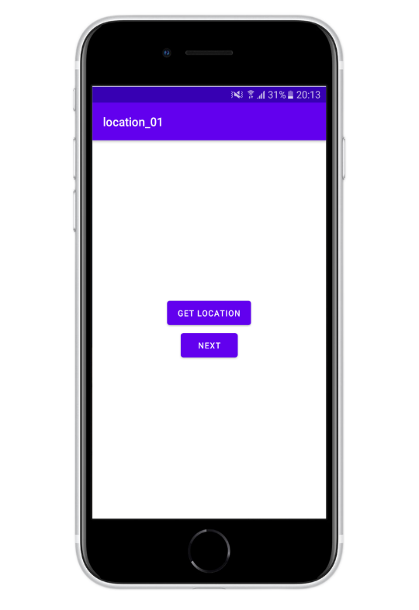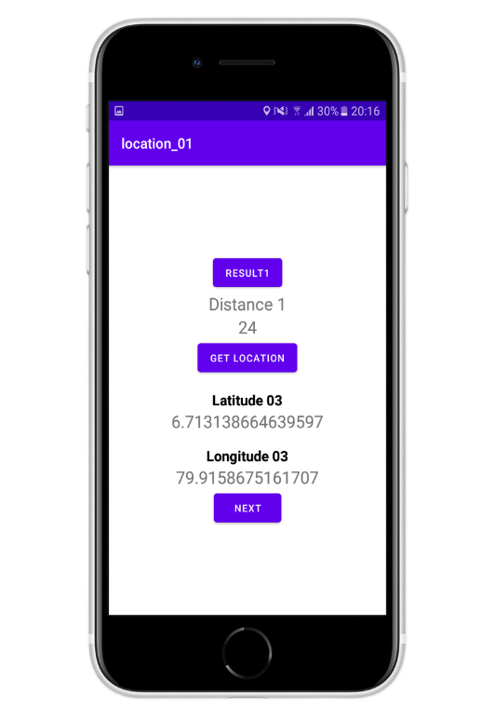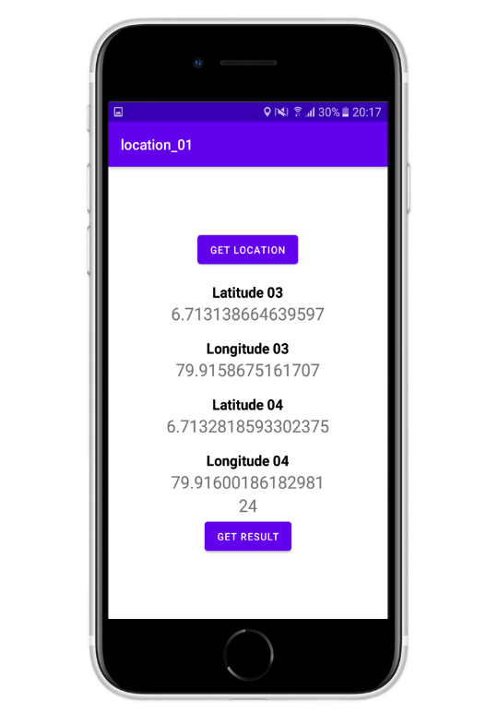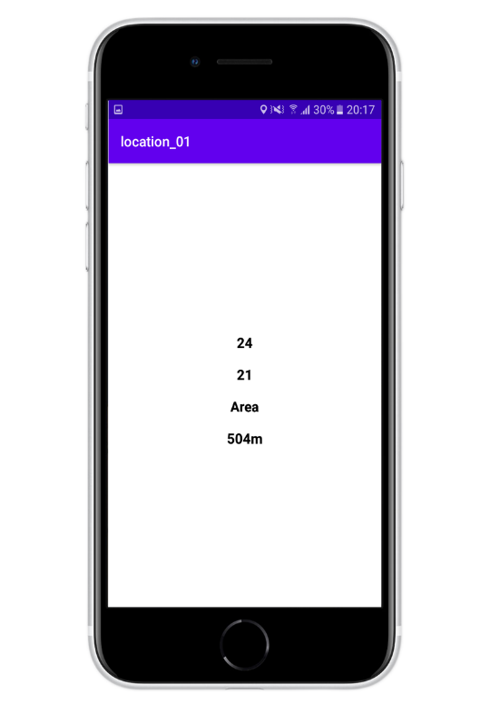

## **6.2 Research Findings**

95.23% training accuracy and 94.20% test accuracy were able to be reached using this model as shown in the examples above with the predictions for the test data shown below. Finally, in order to get the maximum test and the training accuracy hyperparameters were tuned accordingly,

• Batch size – 32

• Epoch - 90

Maximum accuracy was achieved, according to the previously mentioned configurations

Adam optimizer was also used here when it comes to model compilation due to the previously mentioned reasons with categorical cross entropy as this has multiple classes.

## **6.3 Discussion**

After comparing with the other models such as customized AlexNet and custom CNN models, this ResNet model with the above mentioned configurations were found to give the best accuracies for the weed identification task.

## **6.4 Summary of Each Student’s contribution**

* Discovering the best model for fertilizer type identification from a pool of different CNN models
* Discovering the best configurations for that said model to acquire the best results
* Create a feature for calculating the area of the paddy field
* Creating a mobile application for the created components
* Making the application as user friendly as possible
* Find an appropriate dataset to train the models

# **Conclusions**

This research paper was performed in order to provide rice farmers with solutions to the four major issues that they are currently facing which include pests, disease, weeds, fertilizers, and growth defects. In this research four CNN models are compared and contrasted in order to identify which one of them is best suited when it comes to rice and paddy farm datasets. Considering the outputs provided by four models which are used for image classification, the resnet50(modal 02) model performed best with it providing 99.43% for training accuracy and 97.04% for validation accuracy. Some additional research has also been done for the purpose of creating approaches for area calculation of the paddy fields.

# **REFERENCE LIST**

|  |  |
| --- | --- |
| [1] | N. D. Office of Agricultural Affairs, "Sri Lanka: Rice Rebounds - Grain and Feed Annual 2019," USDA Foreign Agricultural Service, 19 09 2019. [Online]. Available: https://www.fas.usda.gov/data/sri-lanka-rice-rebounds-grain-and-feed-annual-2019. [Accessed 23 01 2022]. |
| [2] | J. Weerahewa, S. S. Kodithuwakku and A. Ariyawardana, "Fertilizer subsidy programme in Sri Lanka," ResearchGate, 01 2010. [Online]. Available: https://www.researchgate.net/publication/256186294_Fertilizer_subsidy_programme_in_Sri_Lanka. |
| [3] | "5 Common Fertilizer Software Mistakes Growers Make," smart-fertilizer, 12 02 2020. [Online]. Available: https://www.smart-fertilizer.com/articles/common-fertilizer-management-mistakes/. [Accessed 23 01 2022]. |
| [4] | Q. Zhang, "Computers and Electronics in Agriculture," *ScienceDirect,* vol. 193, 2022. |
| [5] | B. Khiatah and M. , "The Health Impacts of Chemical Fertilizers," amosinstitute, [Online]. Available: https://amosinstitute.com/blog/the-health-impacts-of-chemical-fertilizers/. |
| [6] | P. Kristensen, A. Andersen, L. M. Irgens, A. S. Bye and N. Vagstad, "Testicular cancer and parental use of fertilizers in agriculture," *Cancer Epidemiology and Prevention Biomarkers,* vol. 5, pp. 3-9, 1996. |
| [7] | T. Devitt, "Pesticide, fertilizer mixes linked to range of health problems," news, 15 03 1999. [Online]. Available: https://news.wisc.edu/pesticide-fertilizer-mixes-linked-to-range-of-health-problems/. [Accessed 23 01 2022]. |
| [8] | H. KULATUNGA, "Effects of chemical fertiliser on human health and environment," Sunday Observer, 03 07 2021. [Online]. Available: https://www.sundayobserver.lk/2021/07/04/news-features/effects-chemical-fertiliser-human-health-and-environment#:~:text=One%20of%20the%20key%20environmental. [Accessed 23 01 2022]. |
| [9] | L. Toyoh, L. M. I. Kiyo and M. N. Francis , "Chemical fertilizer application and farmers perception on food safety in Buea, Cameroon," ResearchGate, 01 2017. [Online]. Available: https://www.researchgate.net/publication/311582569_Chemical_fertilizer_application_and_farmers_perception_on_food_safety_in_Buea_Cameroon. [Accessed 23 01 2022]. |
| [10] | Occupational Health & Safety, "The Hidden Dangers of Chemical Fertilizers," Occupational Health & Safety, 01 04 2018. [Online]. Available: https://ohsonline.com/Articles/2017/12/07/The-Hidden-Dangers-of-Chemical-Fertilizers.aspx?Page=2. |
| [11] | Department of Primary Industry, "Fertilisers and the environment," Department of Primary Industry, 2021. [Online]. Available: https://www.dpi.nsw.gov.au/agriculture/soils/guides/soil-nutrients-and-fertilisers/environment. |
| [12] | national informatic center, "On-line fertilizer recommendation system," national informatic center, [Online]. Available: https://www.nic.in/. |
| [13] | K. Hampannavar, V. Bhajantri and S. , "Prediction of Crop Fertilizer Consumption," IEEE Xplore, 2018. [Online]. Available: https://ieeexplore.ieee.org/abstract/document/8697827 . |
| [14] | Government of India Department of Fertilizers, "Integrated Fertilizer Management System," Government of India Department of Fertilizers, [Online]. Available: https://dbtfert.nic.in/iFMS/. |
| [15] | terrabetter, "Rice plant nutrition and Rice Fertilizer," terrabetter, [Online]. Available: http://www.terrabetter.net/html_news/ricefertilizer20110727-3.html. [Accessed 24 01 2022]. |
| [16] | දිනමිණ EPaper, "දිනමිණ EPaper : Dinamina Online EEdition - Lake House - Sri Lanka," දිනමිණ EPaper, [Online]. Available: http://archives.dinamina.lk/epaper/?tday=2013/12/09. [Accessed 31 01 2022]. |
| [17] | S. J. Wimalawansa, "Impact of changing agricultural practices on human health: Chronic kidney disease of multi-factorial origin in Sri Lanka," Researchgate, 5 2014. [Online]. Available: https://www.researchgate.net/figure/Annual-chemical-fertiliser-usage-in-Southeast-Asian-countries-in-2013-fertiliser_fig3_264978995. |

# **Glossary**

CNN – Convolutional Neural Network

FCN — Fully Convolutional Network

SDLC - Software development life cycle

GPS - Global Positioning System

UI – User interface

UX – User experience

# **Appendices**

Screen shots of the Application



